

WIRELESS HEALTH MONITORING DEVICE USING ARDUINO

Project Report

SUBMITTED TO

Dr.KANIMOZHI.G

BY
NAME OF THE STUDENT –REG NO

S:NO | NAME | REG NO
1 | B.CHAITANYA KUMAR REDDY | 19BEE1001
2 | S.ABHISEK | 19BEE1094
3 | P.V.N.S SAI SARAN | 19BEE1103
4 | P.MOHAN SAI | 19BEE1203

SCHOOL OF ELECTRICAL ENGINEERING

VELLORE INSTITUTE OF TECHNOLOGY

CHENNAI,TAMILNADU-600127

April, 2020

Project Report

SUBMITTED TO

Dr.KANIMOZHI.G

BY

NAME OF THE STUDENT –REG NO

S:NO | NAME | REG NO
1 | B.CHAITANYA KUMAR REDDY | 19BEE1001
2 | S.ABHISEK | 19BEE1094
3 | P.V.N.S SAI SARAN | 19BEE1103
4 | P.MOHAN SAI | 19BEE1203

SCHOOL OF ELECTRICAL ENGINEERING

VELLORE INSTITUTE OF TECHNOLOGY

CHENNAI,TAMILNADU-600127

April, 2020

TABLE OF CONTENTS:

FIG 2.1: ARDUINO UNO…………………………………………………… 04

FIG 2.2A: PULSE SENSOR ………………………………………………………….. 06

FIG 2.2B: SENSOR WITH PINS……………………………………………………. 07

FIG 2.3: WIFI MODULE……………………………………………………… 08

FIG 2.4: TEMPERATURE SENSOR ……………………………………………….. 09

FIG 3.1 : THING SPEAK GRAPH ……………………………………………… 11

FIG 3.2 : COMMAND WINDOW…………………………………………………. 12

FIG 4.1 : CIRCUIT DIAGRAM ……………………………………………….. 13

FIG 4.2 : HARDWARE RESULT ………………………………………………. 13

TABLE 2: COMPONENTS & QUANTITY ……………………………. 03

TABLE 2.1: SPECIFICATIONS OF ARDUINO ………………………….. 05

ABBREVATIONS:

C: CENTIGRADE

F: FAHRENHEIT

BPM: BEATS PER MINUTE

LCD: LIQUID – CRYSTAL DISPLAY

LED: LIGHT EMITTING DIODE

PPG: PHOTOPLETHYSMOGRAPHY

ACKNOWLEDGEMENT

We wish to express our sincere thanks and deep sense of gratitude to our project guide, Dr. KANIMOZHI, Associate Professor, VIT SELECT, for her consistent encouragement and valuable guidance offered to us in a pleasant manner throughout the course of the project work.

We are extremely grateful to our Dean Dr. A. PEER FATHIMA of the VIT SELECT, VIT Chennai, for extending the facilities of the School towards our project and for his unstinting support.

We also take this opportunity to thank all the faculty of the School for their support and their wisdom imparted to us throughout the course.

We thank our parents, family, and friends for bearing with us throughout the course of our project and for the opportunity they provided us in undergoing this course in such a prestigious institution.

01

ABSTRACT:

As There is an advancements in Technology and people being more conscious about their health than ever, technical advancements in the field of medicine are inevitable. People are switching towards wearable devices to keep track of their health and fitness related data .This project looks into the development of a heart rate monitor to keep track of the user’s heart rate. The report presents the development of a heart rate monitor interfaced with a module to wirelessly view related data on a smartphone or any other compatible device. The heart rate monitor developed uses the photoplethysmography (PPG) principle to calculate the heart beats per minute & we are also using temperature sensor to sense the human body temperature

The PPG module & Temperature sensor developed is then interfaced with an Arduino Uno board responsible for calculating the beats per minute, temperature. When we kept our fingers on respective sensors then it transfers the serial data to a WIFI module, which transmits the data to LCD device, thingspeak. The results show that the pulse rate & temperature is successfully transferred over Module and could be helpful in emergency or monitoring situations.

02

1.

INTRODUCTION:

Photoplethysmography (PPG) is a low cost optical technique that is able to detect volumetric changes in blood flowing through capillaries from the skin surface.
Photoplethysmography was developed in the late 1800s where scientists observed real-time blood flow using light bulbs. It was in the late 1930s that the term ‘photoplethysmography’ was coined by scientists. With advancement in technology, PPG developments now focus on consumer applications using wearable devices. Temperature sensor is also a nice technique to get the data about it.

These wearable devices are usually connected to a peripheral device to interpret the results obtained. Today, those peripheral devices have been replaced by smartphones to deliver data to consumers in a user friendly manner.

03

2.
COMPONENTS:

Hardware Requirements :

1. Arduino Uno
2. ESP8266 WIFI module
3. Heart beat sensor.
4. Temperature sensor LM 35
5. LED
6. Jumper wires
7. Bread board
8. USB cable ;
9. Resistor: 2k&1k
10. 16*2 LCD Display

Software Requirements :

1. Thing speak
2. Arudino IDE

S.NO | COMPONENTS NAME | RANGE/TYPE | Quantity
1 | PULSE SENSOR | One which helps in eliminating noise from circuit | 1
2 | TEMPERATURE SENSOR | LM35 series | 1
3 | WIFI - MODULE | WSP8266 | 1
4 | LCD DISPLAY | 16*2 RANGE | 1
5 | BREADBOAD &  RESISTORS | Full range 1k & 2k | 1 each

TABLE 2: COMPONENTS & QUANTITY

04

2.1 HARDWARE COMPONENTS:

1. AURDINO UNO:

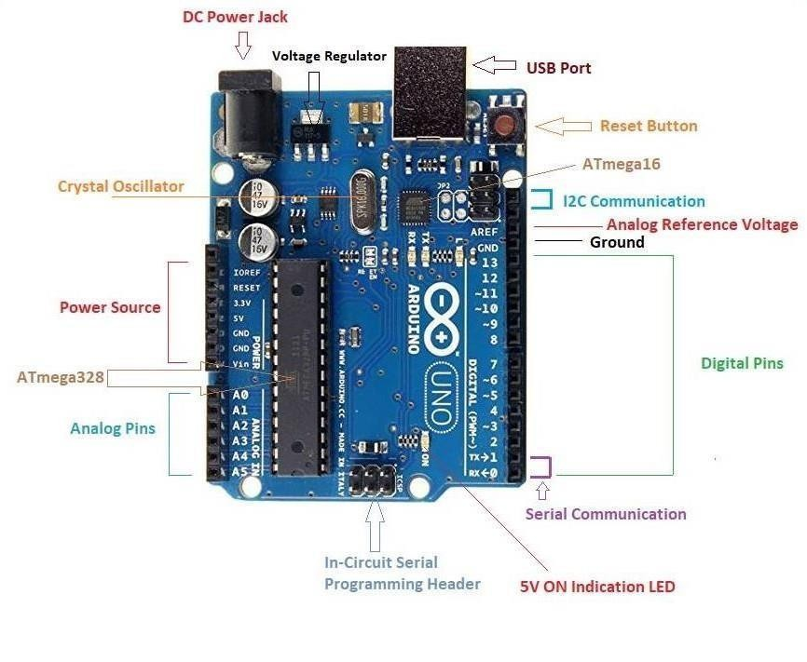
FIG2.1: Arduino Uno

Arduino Uno is a microcontroller board based on the ATmega328P ( datasheet). It has 14 digital input/output pins (of which 6 can be used as PWM outputs), 6 analog inputs, a 16 MHz quartz crystal, a USB connection, a power jack, an ICSP header and a reset button. It contains everything needed to support the microcontroller; simply connect it to a computer with a USB cable or power it with a AC -to-DC adapter or battery to get started. You can tinker with your UNO without too much about doing something wrong, worst case scenario you can replace the chip for a few dollars and start over again"Uno" means one in Italian and was chosen to mark the release of Arduino Software (IDE) 1.0. The Uno board and version 1.0 of Arduino Software (IDE) were the reference versions of Arduino, now evolved to newer releases. The Uno board is the first in a series of USB Arduino boards, and the reference model for the Arduino platform; for an extensive list of current, past or outdated boards see the Arduino index of boards.

07

GENERAL PIN FUNCTIONS

LED: There is a built-in LED driven by digital pin 13. When the pin is HIGH value, the LED is on, when the pin is LOW, it's off.
VIN: The input voltage to the Arduino/Genuino board when it's using an external power source (as opposed to 5 volts from the USB connection or other regulated power source). You can supply voltage through this pin, or, if supplying voltage via the power jack, access it through this pin.
5V: This pin outputs a regulated 5V from the regulator on the board. The board can be supplied with power either from the DC power jack (7 - 20V), the USB connector (5V), or the VIN pin of the board (7-20V). Supplying voltage via the 5V or 3.3V pins bypasses the regulator, and can damage the board.
3V3: A 3.3 volt supply generated by the on-board regulator. Maximum current draw is 50 mA.
GND: Ground pins.
IOREF: This pin on the Arduino/Genuino board provides the voltage reference with which the microcontroller operates. A properly configured shield can read the IOREF pin voltage and select the appropriate power source or enable voltage translators on the outputs to work with the 5V or 3.3V.
Reset: Typically used to add a reset button to shields which block the one on the board

TECHNICAL SPECIFICATION OF ARDUINO BOARD:

Microcontroller | ATmega328P
Input Voltage (recommended) | 7-12V
Operating voltage | 5v
Input Voltage(limit) | 6-20V
Digital I/O Pins | 6-20v14 (of which 6 provide PWM
Digital I/O Pins | output)
PWM Digital I/O Pins | 632
Analog Input Pins | 6
DC Current per I/O Pin | 20mA
DC Current for 3.3V Pin | 50mA
Flash Memory | KB (ATmega328P) of which 0.5 KB used by bootloader
SRAM | 2 KB (ATmega328P)
EEPROM | 1 KB (ATmega328P)
Clock Speed | 16 MHz
LED_BUILTIN | 13
Length | 68.6 mm
Width | 53.4mm
Weight | 25 g

TABLE 2.1: SPECIFICATIONS OF ARDUINO

2. PULSE SENSOR:

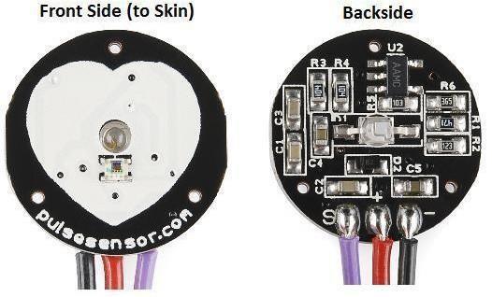
FIG 2.2A: PULSE SENSOR
07

It is an Open Source heart rate monitor which considered as a PPG device used to monitor the non-invasive heart rate. It measures the real-time heart beats and calculates BPM with the aid of algorithms implemented by Arduino. This sensor has two sides, the front one which has a heart shape is the side to be attached to the skin. The pins of the pulse sensors are three .If the frond side is facing you, then the most left pin is the GND while the middle one is the input voltage which will be connected to the +5v of the Arduino. The last one for outputting the electrical and will be wired with the analog bins of the Arduino.
The Pulse sensor converts the physical PPG into electrical signals. The sensor outputs a raw signal of analog voltage fluctuations, amplifies it and normalize the wave at V/2.
With every beat of the heart, a pulse wave travel along all arteries to the tissues where the Pulse Sensor is attached. When this pulse wave goes under the sensor, the signal experiences arapid upward rise in its value. It falls back down toward the normal point and before the next pulse sensor goes under the sensor, the signal stabilizes to the ambient noise.
Due to the repetitive characteristic of the pulse wave, the peak is chosen as a reference point because it’s recognizable. By applying calculation algorithm on the time between each two successive peaks the heart rate is measured. Ideally we want to find the instantaneous moment of the heart beat for accurate measurements. According to heart researchers, the instantaneous moment is when the signal gets 25% or 50% of its amplitude. This pulse sensor first measures the IBI when the signal gets 50% of the amplitude, which from the BPM is derived from average of 10 IBI times.

Clip the Pulse Sensor to your earlobe or fingertip and plug it into your Arduino, you can ready to read heart rate.
The pulse sensor has three pins: VCC, GND & Analog Pin.


08

FIG 2.2B: SENSOR WITH PINS

3. ESP8266 WIFI MODULE:

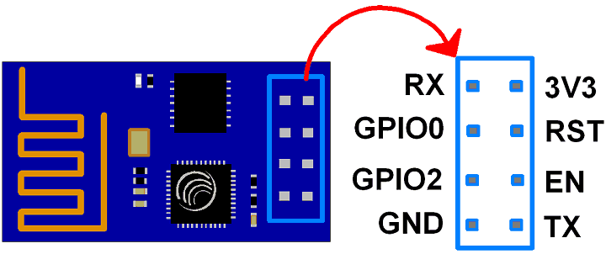

FIG 2.3: WIFI MODULE

The ESP8266 is a very user-friendly and low-cost device to provide internet connectivity to your projects. The module can work both as an Access point (can create hotspot) and as a station (can connect to Wi-Fi), hence it can easily fetch data and upload it to the internet making the Internet of Things as easy as possible. It can also fetch data from the internet using API’s hence your project could access any information that is available on the internet, thus making it smarter. Another exciting feature of this module is that it can be programmed using the Arduino IDE which makes it a lot more user friendly.

The ESP8266 module works with 3.3V only, anything more than 3.7V would kill the module hence be cautions with your circuits. Here is its pins description.

09
Pin 1: Ground: Connected to the ground of the circuit
Pin 2: Tx/GPIO – 1: Connected to Rx pin of programmer to upload program
Pin 3: GPIO – 2: General purpose Input/output pin
Pin 4 : CH_EN: Chip Enable/Active high
Pin 5: Flash/GPIO – 0: General purpose Input/output pin
Pin 6 : Reset: Resets the module
Pin 7: RX/GPIO – 3: General purpose Input/output pin
Pin 8: Vcc: Connect to +3.3V only

4. TEMPERATURE SENSOR:

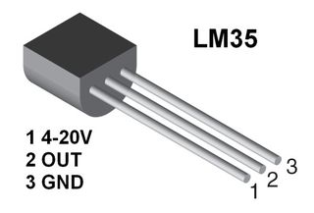

FIG 2.4: TEMPERATURE SENSOR

The LM35 series are precision integrated-circuit temperature devices with an output voltage linearly-proportional to the Centigrade temperature. The LM35 device has an advantage over linear temperature sensors calibrated in Kelvin, as the user is not required to subtract a large constant voltage from the output to obtain convenient Centigrascaling.
10

The LM35 device does not require any external calibration or trimming to provide typical accuracies of ±¼°C at room temperature and ±¾°C over a full −55°C to 150°C temperature range.

2.2 SOFTWARE COMPONENTS:

SOFTWARER USED&SHORT DESCRIPTION OF SOFTWARE:

THINGSPEAK:
ThingSpeak is a platform providing various services exclusively targeted for building IoT applications. It offers the capabilities of real-time data collection, visualizing the collected data in the form of charts, ability to create plugins and apps for collaborating with web services, social network and other APIs. We will consider each of these features in detail below.
The core element of ThingSpeak is a ‘ThingSpeak Channel’. A channel stores the data that we send to ThingSpeak and comprises of the below elements:
8 fields for storing data of any type - These can be used to store the data from a sensor or from an embedded device.

3 location fields - Can be used to store the latitude, longitude and the elevation. These are very useful for tracking a moving device.

11
1 status field - A short message to describe the data stored in the channel.
To use ThingSpeak, we need to signup and create a channel.

Once we have a channel, we can send the data, allow ThingSpeak to process it and also retrieve the same. Let us start exploring ThingSpeak by signing up and setting up a channel.

3. SIMULATION RESULTS:

After the hardware connections had done then connect that hardware circuit to the Arduino after this step, compile the code which we have to use for Arduino to run give the code in Arduino IDE & compile it.

After a min /few seconds it allow the sensor by indicating a bulb glow in the sensor. placing the fingers on respective sensors …we will get these graphical peaks and the values in the command prompt.

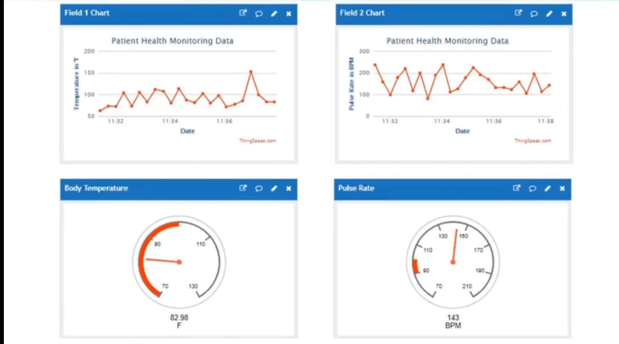
FIG 3.1 : THING SPEAK GRAPH
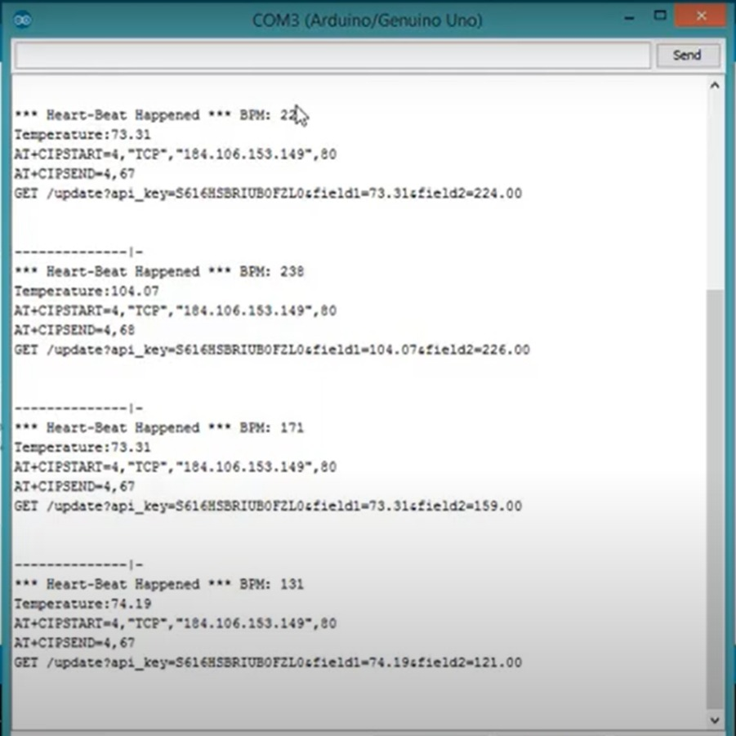
12

FIG 3.2 : COMMOND WINDOW

4. HARDWARE RESULT:

CIRCUIT :

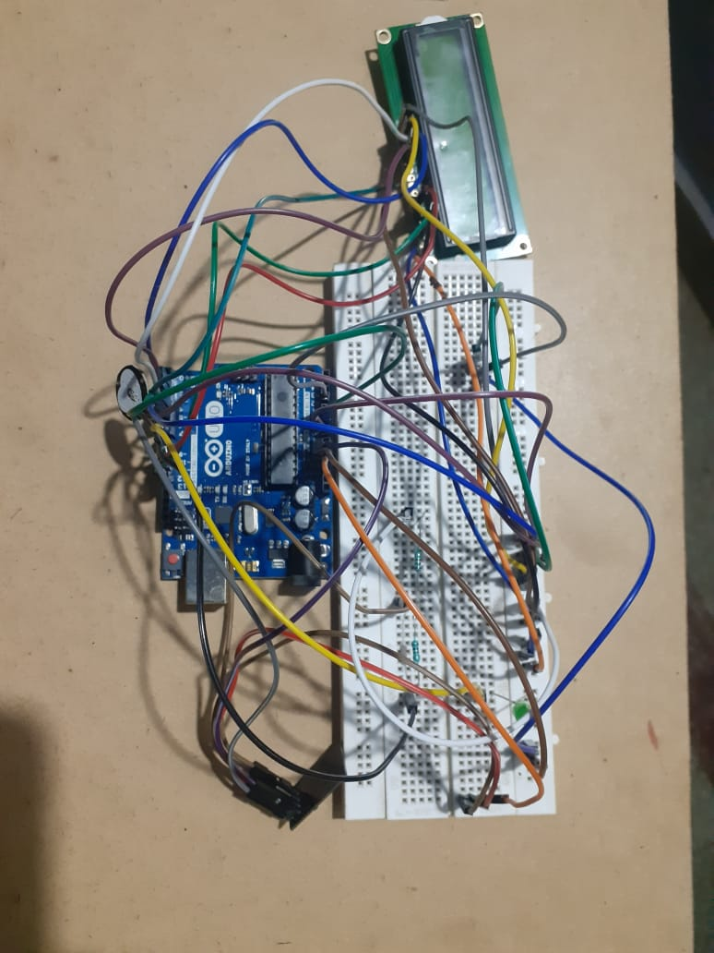

FIG 4.1 : CIRCUIT DIAGRAM

RESULTS:

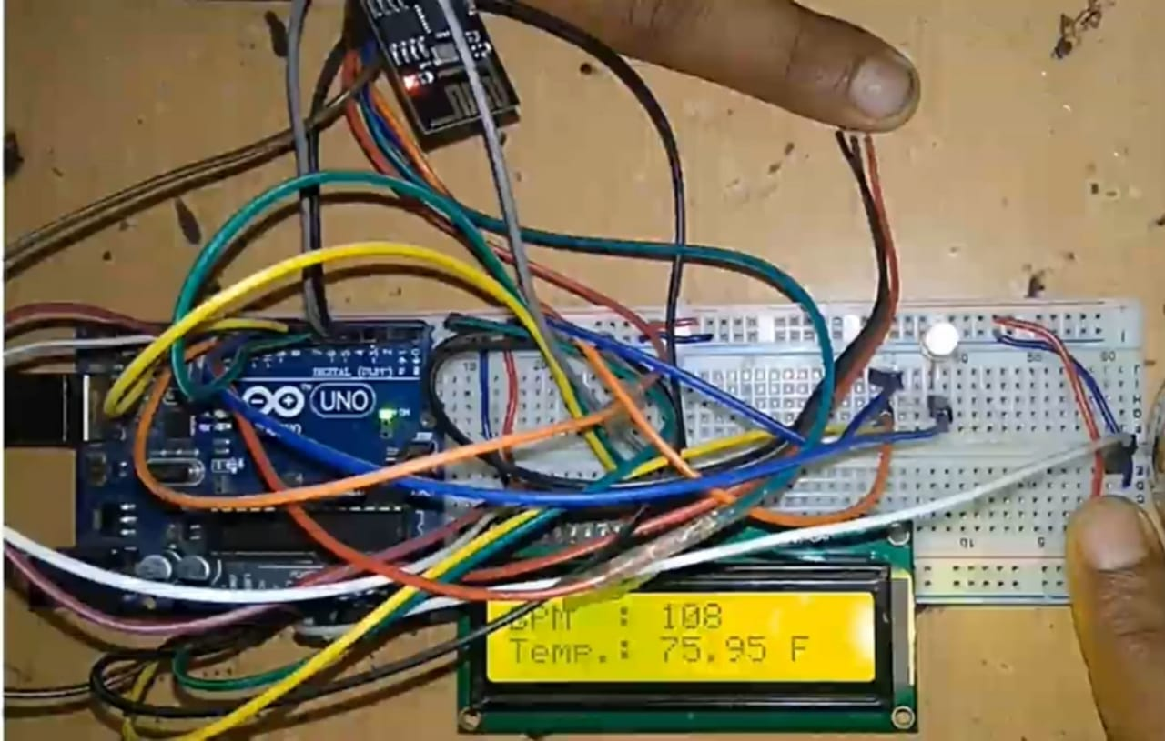

FIG 4.2 : HARDWARE RESULT
14

5.RESULTS & DISCUSSION:

The increased use of mobile technologies and smart devices in the area of health has caused great impact on the world. Health experts are increasingly taking advantage of the benefits these technologies bring, thus generating a significant improvement in health care in clinical settings and out of them. Likewise, countless ordinary users are being served from the advantages of the M-Health (Mobile Health) applications and E-Health (health care supported by ICT) to improve, help and assist their health. Applications that have had a major refuge for these users, so intuitive environment. The Internet of things is increasingly allowing to integrate devices capable of connecting to the Internet and provide information on the state of health of patients and provide information in real time to doctors who assist. It is clear that chronic diseases such as diabetes, heart and pressure among others, are remarkable in the world economic and social level problem. The aim of this article is to develop an architecture based on an ontology capable of monitoring the health and workout routine recommendations to patients with chronic diseases .

6.CONCLUSION:

By Analysing the output signal frequency from the heartbeat sensor we found that which signal is to considered as heartbeat. the correct simulation of heartbeat on the display and as well as on the computer system and theses output signal frequency will also help to refer the body temperature.

15

7.REFERENCE:

J. Allen, “Photoplethysmography and its application in clinical physiological measurement,”
Physiol. Meas, vol. 28, pp. R1 – R39, 2007.

P. A. Kyriacou, “Investigation of new electro-optical techniques for monitoring patients,” Ph.D. dissertation, Dept. Med. Electronics and Physics, University of London, London, England, April 2001.

